|  | 2814ICT/7003ICT – Data Management / Database Design  School of Information & Communication Technology |
| --- | --- |

**Lab 5.1 Exercise**

**1. Write the MySQL statements to update a database.**

For the given MovieCo ERD below, write MySQL statements:

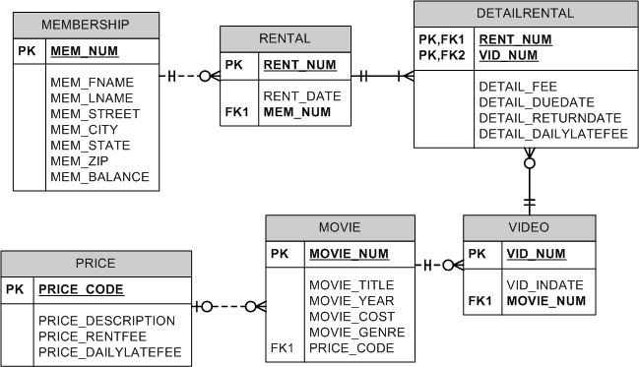

***Hints:*  See Topic 4.1 materials (Parts 4 & 5).**

a) Write a SQL command to add a new column MEM_PHONE of datatype CHAR(10) to MEMBERSHIP table.

**Your answer:**

ALTER TABLE MEMBERSHIP

ADD MEM_PHONE CHAR(10);

b) Write a SQL command to change the phone number of member number 108 to 0435864566.

**Your answer:**

UPDATE MEMBERSHIP SET MEM_PHONE =’0435864566’ WHERE MEM_NUM=’108’;

c) Write a SQL command to delete the column MEM_PHONE from MEMBERSHIP table.

**Your answer:**

ALTER TABLE MEMBERSHIP

DROP COLUMN MEM_PHONE ;

d) Write a single SQL command to increase all price rental fee values in the PRICE table by $0.50.

**Your answer:**

UPDATE PRICE SET PRICE_RENFEE= (PRICE_RENFEE+0.5)